**Introduction**

Welcome to GGG gym. We have a nice service and smiling face.    
We have the new treadmills machine. It can store your training data. Just help you be better.    
Join us! Container our accounting consultant.

We have two roles for the system.

Normal user. They can use the treadmills machine. Haven ranking list for treadmills record in every day. Have table information about the best private coach in the month.

System user. They maintain machine information. Charge for Every private course record.

**Program software**

Axure 8

Apache NetBeans IDE 12.6

MySql 5.7

Jakarta EE 8

JDK 12

ER design

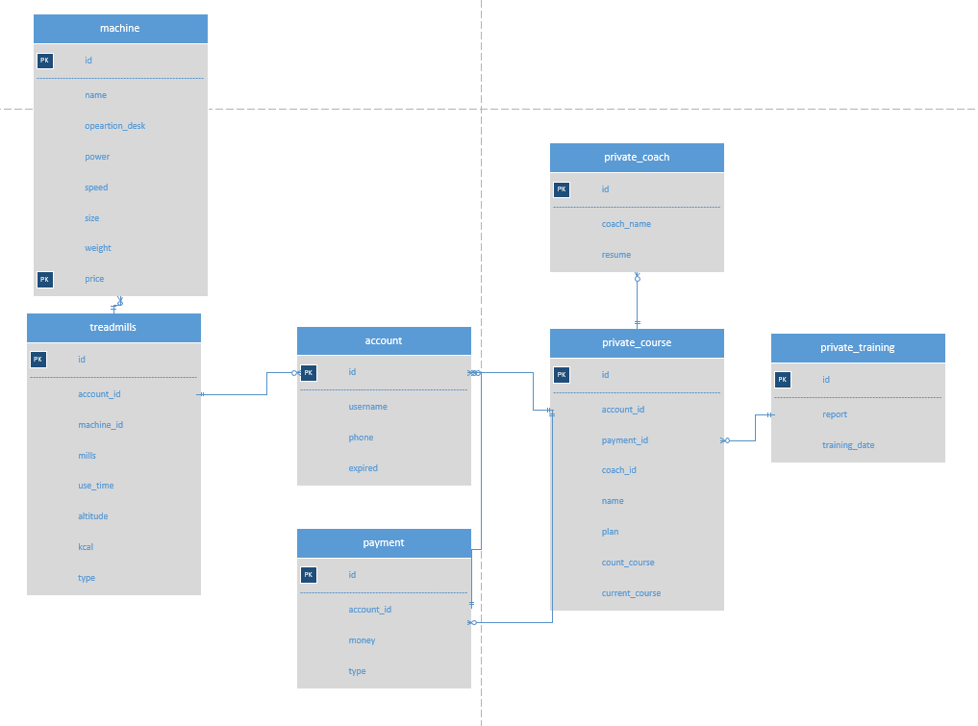

I have to use the Rapid prototyping tool.

If you have Axure 8. Please open the file ”fp.rp”.

Let us watch the system design.

We have a login page. It has base validation.

When your login success. After It will have two pages for different use. One page for normal use. One page for system manager, This page will have a system menu.

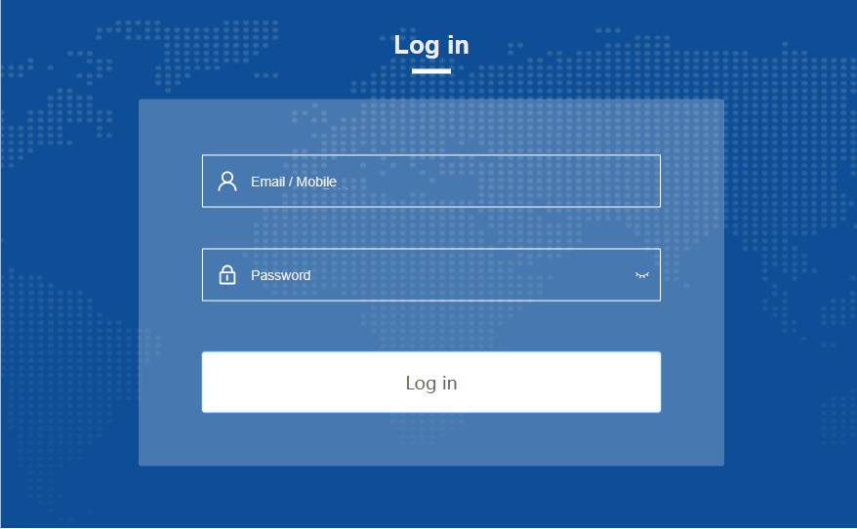

Home page for normal.

The left ranking list is for every day about treadmills machine data.

Right table for private coach complete course situation.

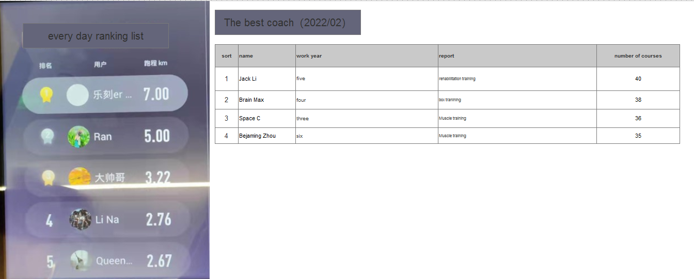

Home page for system management.

Left is the system menu.

The left ranking list is for every day about treadmills machine data.

Right table for private coach complete course situation.

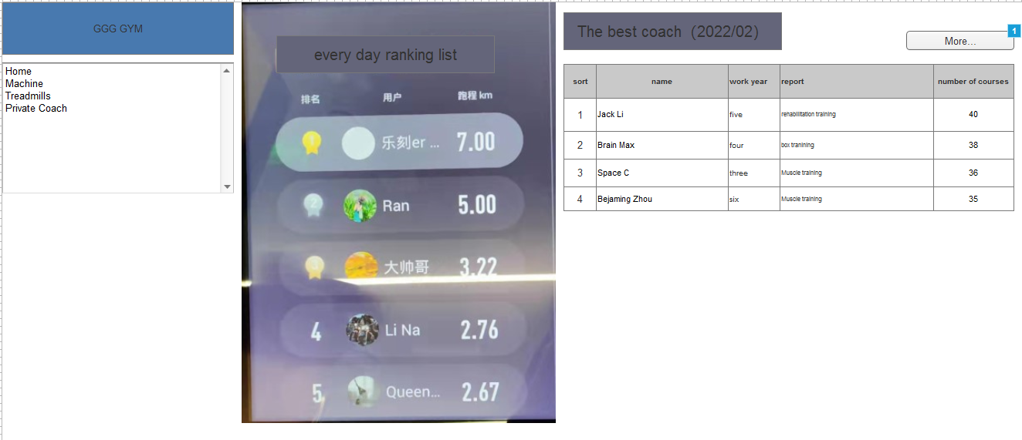

Machine manage page.

We have some Intelligent treadmill machine is buy new. And you can have some records in the app.

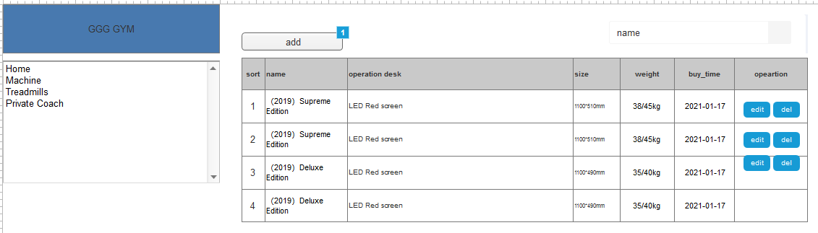

Treadmills use the record page.

When using the app login to the machine. We will record your training information.

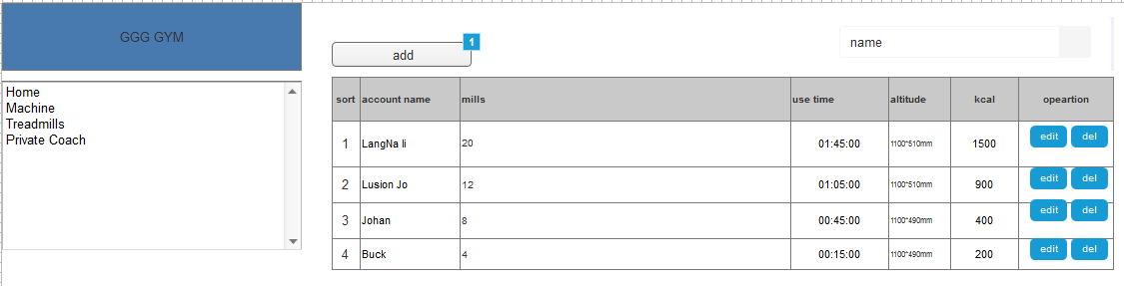

Private coach page.

The boss cares about who is the best, how many lessons they sell, and how many lessons they deal with.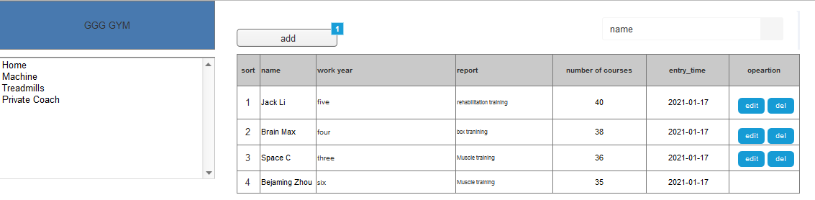

**Differences between Java EE and Java SE**

Java Platform, Standard Edition (Java SE)

Java SE is the first course for java. Java SE's API provides the core functionality of the Java programming language. It tells us. Java is a high-level language for OOP. Learning Inheritance, Polymorphism, Abstraction, encapsulation.

After we will learn swing for client/server programs. To install the program we need to install the client program file. Every time for an update. Need download and install for release program file.

Java Platform, Enterprise Edition (Java EE)

Java EE , or J2EE (Java 2 Enterprise Edition) basic is mean Servlet and JSP(Java Servlet page). It running a will web context server. such as Tomcat and Jetty. The browser/server

to release program. Every computer has a browser. Most import client does not need updated software for program update. It’s very important. Haven many web systems then will have release for update fast than a week for deploy. After the client will experience new requirements and give some new requirements of the product. It’s like a cycle service.

**What does enterprise**

**A short definition:** enterprise software is meant to satisfy the needs of an organization. Help employees reduce duplication of work.

**Interconnectivity:**

Some government departments they a lot of systems. I am for a different software company. Then will have a lot of accounts for a different system. It has the same product. With the migration of time, user roles and data become data islands. In particular, the situation of departmental cooperation.

**Cost:**

Most businesses are key to seeing a return on their investment as soon as possible.

Usually have initial outlay and ongoing maintenance. Some will also include hardware or cloud server purchases. Because the client company has no software departments.

**Java Community Process (JCP):**

The process is mean developing or revising Java technology specifications.(*The Java Community Process(SM) Program).*

Generally speaking, JCP is a version control group. Review by the expert group. Like, Develop submit code to code management tools. After being reviewed by the quality review team, it will be updated in the next version. The transition from Java EE to Jakarta EE.

**Jakarta EE Specification Process (JESP)**

Apply a new project for java ee. Createa a document api. Names and scope. It will decide the maven group. What package path you will use. In short, you need to submit a new project to Eclipse Foundation.

*Jakarta EE 8 Specification Projects*. (2019).

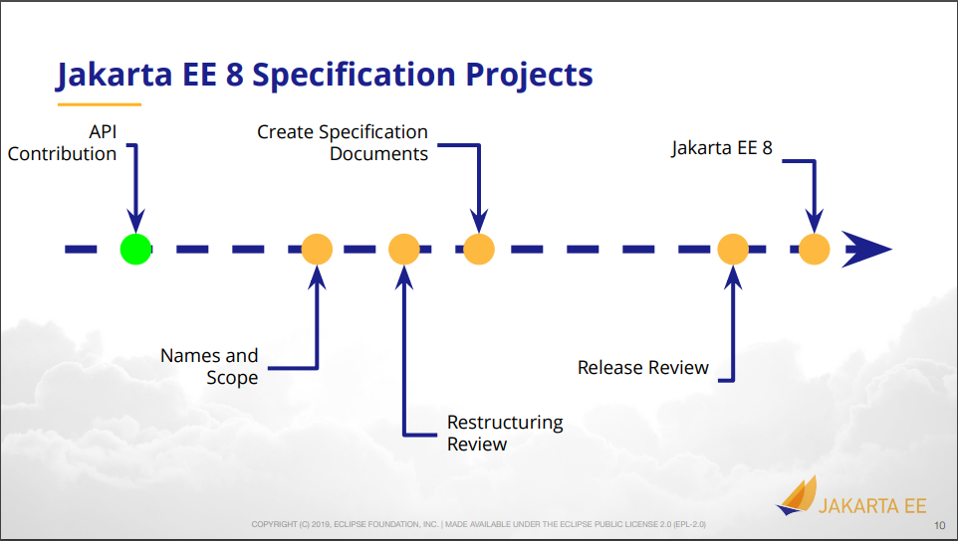

**Powerful JPA**

JDBC is the manufacturer's standard for connecting most databases in Java. JPA (full name) is a powerful tool developed based on JDBC. It operates data objects in an object-oriented way. Support automatic encapsulation of attributes. Support multiple SQL configuration methods, such as query and native query.

**Object-Relation Mapping**

Developers often find it easier to work with Java objects rather than Structured Query Language(SQL) for relational data. (Jakarta EE Recipes)

Java is the oop language. Basic use of SQL CURL is like process programing. We need to code everything about database operation. And write the hard code for DDL. Always we will convert the result to Java Object.

Use java bean to mapped to a database table. Then will less more sam code for DDL. It supports SQL operation. When you use the IDE you will see the SQL execute log.

Object-relational mapping implements is the configuration of annotation/XML to persist any Java object directly to a database table. Class name and property name are not the same as to table. Can use many Objects to map one table for business required.

There has more information about JPA.(V. (2020, September 16). Why and when you should use JPA.)

(*Overview (Jakarta Persistence API documentation)*. (2019))

|  |  |
| --- | --- |
| **Jakarta Persistence API Packages** | |
| **Package** | **Description** |
| [**javax.persistence**](https://jakarta.ee/specifications/persistence/2.2/apidocs/javax/persistence/package-summary.html) | Jakarta Persistence is the API for  the management for **persistence** and object/relational mapping. |
| [**javax.persistence.criteria**](https://jakarta.ee/specifications/persistence/2.2/apidocs/javax/persistence/criteria/package-summary.html) | Jakarta Persistence Criteria API |
| [**javax.persistence.metamodel**](https://jakarta.ee/specifications/persistence/2.2/apidocs/javax/persistence/metamodel/package-summary.html) | Jakarta Persistence Metamodel API |
| [**javax.persistence.spi**](https://jakarta.ee/specifications/persistence/2.2/apidocs/javax/persistence/spi/package-summary.html) | SPI for Jakarta Persistence providers |

**EclipseLink**

EclipseLink, built by the Eclipse Foundation, provides an open-sourced JPA implementation.

EclipseLink is JPA’s reference implementation and implements JPA version 2.2. It was one of the first projects that became part of EE4J.

<https://projects.eclipse.org/projects/ee4j.jaxb>

(Varma, S. (2020, July 9). *What are JPA and Java Persistence API implementation)*

There are several Object Relational Mapping implementations. Following are the popular ORM implementations.

Hibernate – Open Source

Top Link – By Oracle

Eclipse Link – Eclipse Persistence Platform

Open JPA – By Apache

MyBatis – Open Source – Formerly known as iBATIS

Many More …

**References**

*Jakarta EE Recipes: A Problem-Solution Approach* (1st ed.). (2020). Apress.

V. (2020, September 16). *Why and when you should use JPA*. Vlad Mihalcea. https://vladmihalcea.com/why-and-when-use-jpa/

*Jakarta EE Platform Project*. (2021, May 17). Jakarta EE 9.1. <https://eclipse-ee4j.github.io/jakartaee-platform/>

*The Java Community Process(SM) Program - JCP Procedures - JCP 2: Process Document*. (2019). JCP 2: Process Document. <https://jcp.org/en/procedures/jcp2>

*Transition from Java EE to Jakarta EE*. (2020b). Java Magazine. https://blogs.oracle.com/javamagazine/post/transition-from-java-ee-to-jakarta-ee

Guindon, C. (2021). *Jakarta EE Specification Process | The Eclipse Foundation*. Jakarta® EE: The New Home of Cloud Native Java. https://jakarta.ee/about/jesp/

*Jakarta EE 8 Specification Projects*. (2019). [Eclipse Foundation]. https://jcp.org/aboutJava/communityprocess/ec-public/materials/2019-05-15/Jakarta_EE_Update_May2019.pdf

Varma, S. (2020, July 9). *What is JPA and Java Persistence API implementation?* Java Tutorials. https://javabydeveloper.com/what-is-java-persistence-api/

*Overview (Jakarta Persistence API documentation)*. (2019). Jakarta Persistence API Packages. https://jakarta.ee/specifications/persistence/2.2/apidocs/